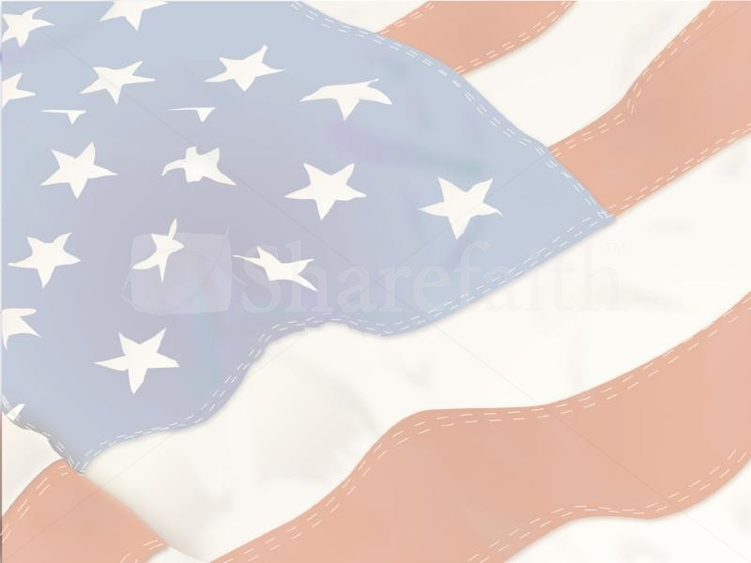
OLD Farts and Family Team Tournament

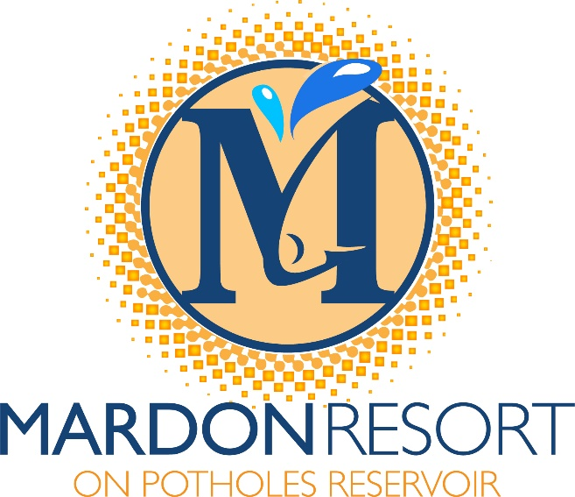

Date: September 15, 2018
Location: MarDon Resort
Time: One day tournament
Registration Friday-MarDon office
Registration Sat.-MarDon store 5am
5:30 a.m. Drivers meeting
Fish 6:00 a.m. to 3:00 p.m.

To be eligible just one team
member must be 40 years+.old or older.

MARDON RESORT IS PROUD TO SPONSOR THIS FISHING TOURNAMENT WHICH IS OPEN TO ALL
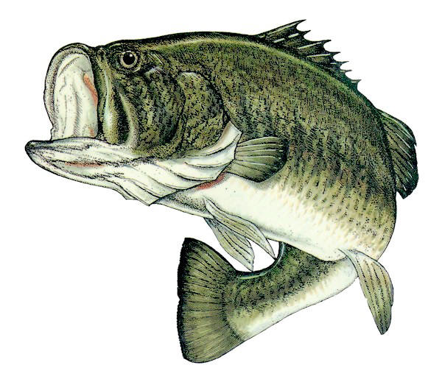
Details:
Entry fee: $150.00 per team
$25 big fish option
$25 big stringer option
Payout: 80%
CWFAC Event 501C-3 Non-profit event. Net monies used for Potholes Reservoir underwater habitat project.
ONLY PROP DRIVEN OUTBOARD MOTORS ALLOWED, NO AIR BOATS OR JET BOATS ALLOWED.

Detach Entry form below and mail to: MarDon Resort 8198 Hwy 262 SE Othello, WA 99344/Checks Payable to CWFAC
Boater: Non-Boater:
Name: Name:
Address: Address:

Phone #: Phone:
By my signature, I release from liability, MarDon Resort and all tournament officials. I understand I am responsible for my actions during this event, I will abide by the rules and conduct myself in a sportsman-like manner at all times.
Boater: Non-Boater:

